ProMik Boundary Scan Concept
  - For internal use only

Revision
Version | Date | Author | Description
0.1 | 23.07.2021 | Kristian Trenkel | Initial version
0.2 | 27.07.2021 | Kristian Trenkel | Rework
0.3 | 30.07.2021 | Kristian Trenkel | Update Milestones
0.4 | 04.08.2021 | Kristian Trenkel | Update test definition
0.5 | 15.02.2022 | Razvan Matis | Added usage of library section

1. Introduction 5
2. Workflow 6
3. Use cases – customer view 8
1) Creation of test vectors by ProMik and execution by customer 8
2) Creation and execution of the test vectors by the customer 8
4. Scope of delivery and dependencies 9
5. Technical Implementation 10
a. Overview 10
b. Control of the targets 12
c. Recognised patterns and test cases 13
d. Integration into the overall process – POnline_Pro 18
e. Integration into the overall process – FlashTask_Pro 19
6. Verification and Validation 20
a. ZedBoard 20
b. TriBoard TC3X7 V20 21
c. Customer Application – ADC418AI12 23
7. Milestone Plan 24
8. Usage of the console application library 25
a. ProjectFileHandler 25
All methods in detail 25
b. ProjectLoadHandler 28
All methods in detail 29
c. BoundaryScanObjectDeterminationHandler 30
All methods in detail 31
d. JtagPinInformationHandler 31
All methods in detail 31
e. SvfFileCreationHandler 32
All methods in detail 32
f. BoundaryScanReportHandler 33
All methods in detail 33
Sequence diagram of the whole usage 34
Usage example with source code 35

Introduction
This document describes the planning and implementation of the Boundray Scan solution for the ProMik product line. The aim is to extend the functionality of the ProMik programmers (MSP21xx and successors) by the possibility to execute boundary scan tests via test vectors. This should increase the benefit for the customer.
The following goals should be achieved:
- Easy-to-use boundary scan solution for customers
- Generation of test vectors from layout data (ODB++), BOM and BSDL files.
- Generation of test vectors should be as automated as possible
- There must be a clear error message for the customer – recognisability change component and network has the error
- Test coverage must be automatically determined and a report generated for the customer
- Integration with FlashTask_Pro and POnline_Pro must be provided

Limitation:
- The tests focus on infrastructure and interconnection testing.
- More complex tests, such as RAM tests, are to be performed via SMART ICT and bootloader.

Workflow
The Figure 1 below shows a general overview of the planned process.
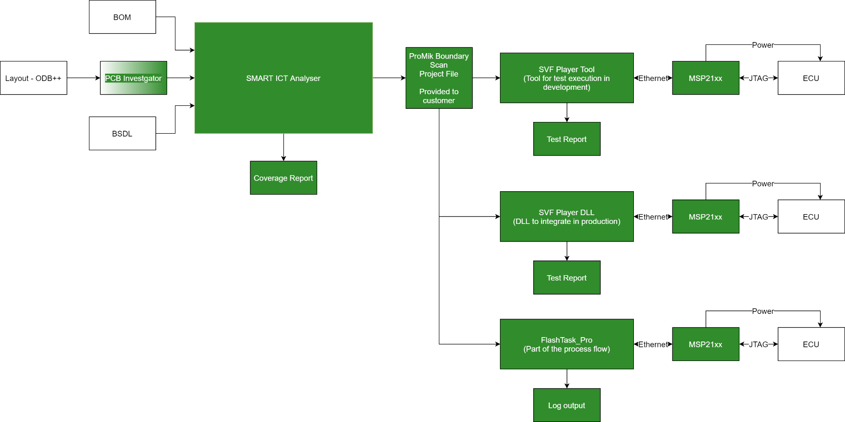
Figure 1: Workflow Overview
The central point of the process is the ProMik Boundary Scan Project file. This file contains the test vectors, BSDL files and other metadata.
The data structure for the ProMik Boundary Scan Project must be expandable.
It is intended to use a directory structure within a ZIP archive with a manifest file. The manifest file should contain the following information:
- Version number
- Paths to the files within the project file
- …

The project file itself must contain all data necessary for the execution. These are:
- Test vectors
- BSDL file(s)
- …
A first draft of the structure looks as follows:
1 level | 2 level | 3 level | Description
bsdl | - | - | Folder for the BSDL file(s)
- | <BSDL file(s)> | - | BSDL file for every Boundary Scan device in the project
jsonProject | - | - | Folder for project file
- | jsonProject.json | - | Project file
svf |  |  | Folder with all the SVF test vectors nested in subdirectories
- | <Folder per device> | - | One folder per Boundary Scan device
- | - | <Folder per pattern / test case> | Folger with all SVF test vectors pro a specific test case resp. pattern
project.manifest | - | - | Manifest file with version number and references to the files in the project structure

To secure the data, the ZIP archive is encrypted and password protected.

Use cases – customer view
From the customer's point of view, there are various use cases:

Creation of test vectors by ProMik and execution by customer
In this case, the SMART ICT Analyser is only used with ProMik. The client uses the SVF Player or FlashTask_Pro to run the boundary scan test in the form of the ProMik Boundary Scan Project file and the included SVF test vectors.
- During Development
The client's developer or test engineer wants to execute and test individual or all test cases. This can be done via the SVF Player Tool. A meaningful output of the errors and their export into a format that can be processed further (e.g. CSV) is necessary.
- During Production – ProOnline_Pro/DLL
In this case, the SVF Player DLL is available to the customer and he can execute the tests via the interface of the DLL, as with the SVF Player Tool.
- During Production – FlashTask_Pro
In this case, the execution of the SVF test vectors is part of the process mapped by FlashTask_Pro. For this purpose, the SVF player functionality must be integrated transparently.

Creation and execution of the test vectors by the customer
In this case, the SMART ICT Analyser is also used at the client's site. As in case 1), the client uses the SVF Player or FlashTask_Pro to run the boundary scan test in the form of the ProMik Boundary Scan Project file and the SVF test vectors it contains.
In this case the use cases are the same like in 1). The important difference is the use of the SMART ICT Analyser at the customer's site. This requires a correspondingly simple operation of the tool. Furthermore, documentation and training possibilities must be developed.

To be clarified:
- Delivery of the SMART ICT Analyser requires good operability as well as documentation and key documents

Scope of delivery and dependencies
Derived from the workflow and the components, the following deliveries are possible:
- Tools/Software
  - SVF Player Tool and SVF Player DLL
  - FlashTask_Pro with Boundary Scan integration
  - SMART ICT Anaylser – PCB Investigator needed
- Service:
  - Creation of the SVF test vectors
  - FlashTask_Pro Integration (GUI)?
  - Customer specific extension of test case generation

Technical Implementation
This chapter describes the previous planning and implementation as well as the further development.

Overview
In Figure 2 the planed architecture for the Boundary Scan solution of ProMik is shown. This shows a general overview, which is not yet fully implemented.
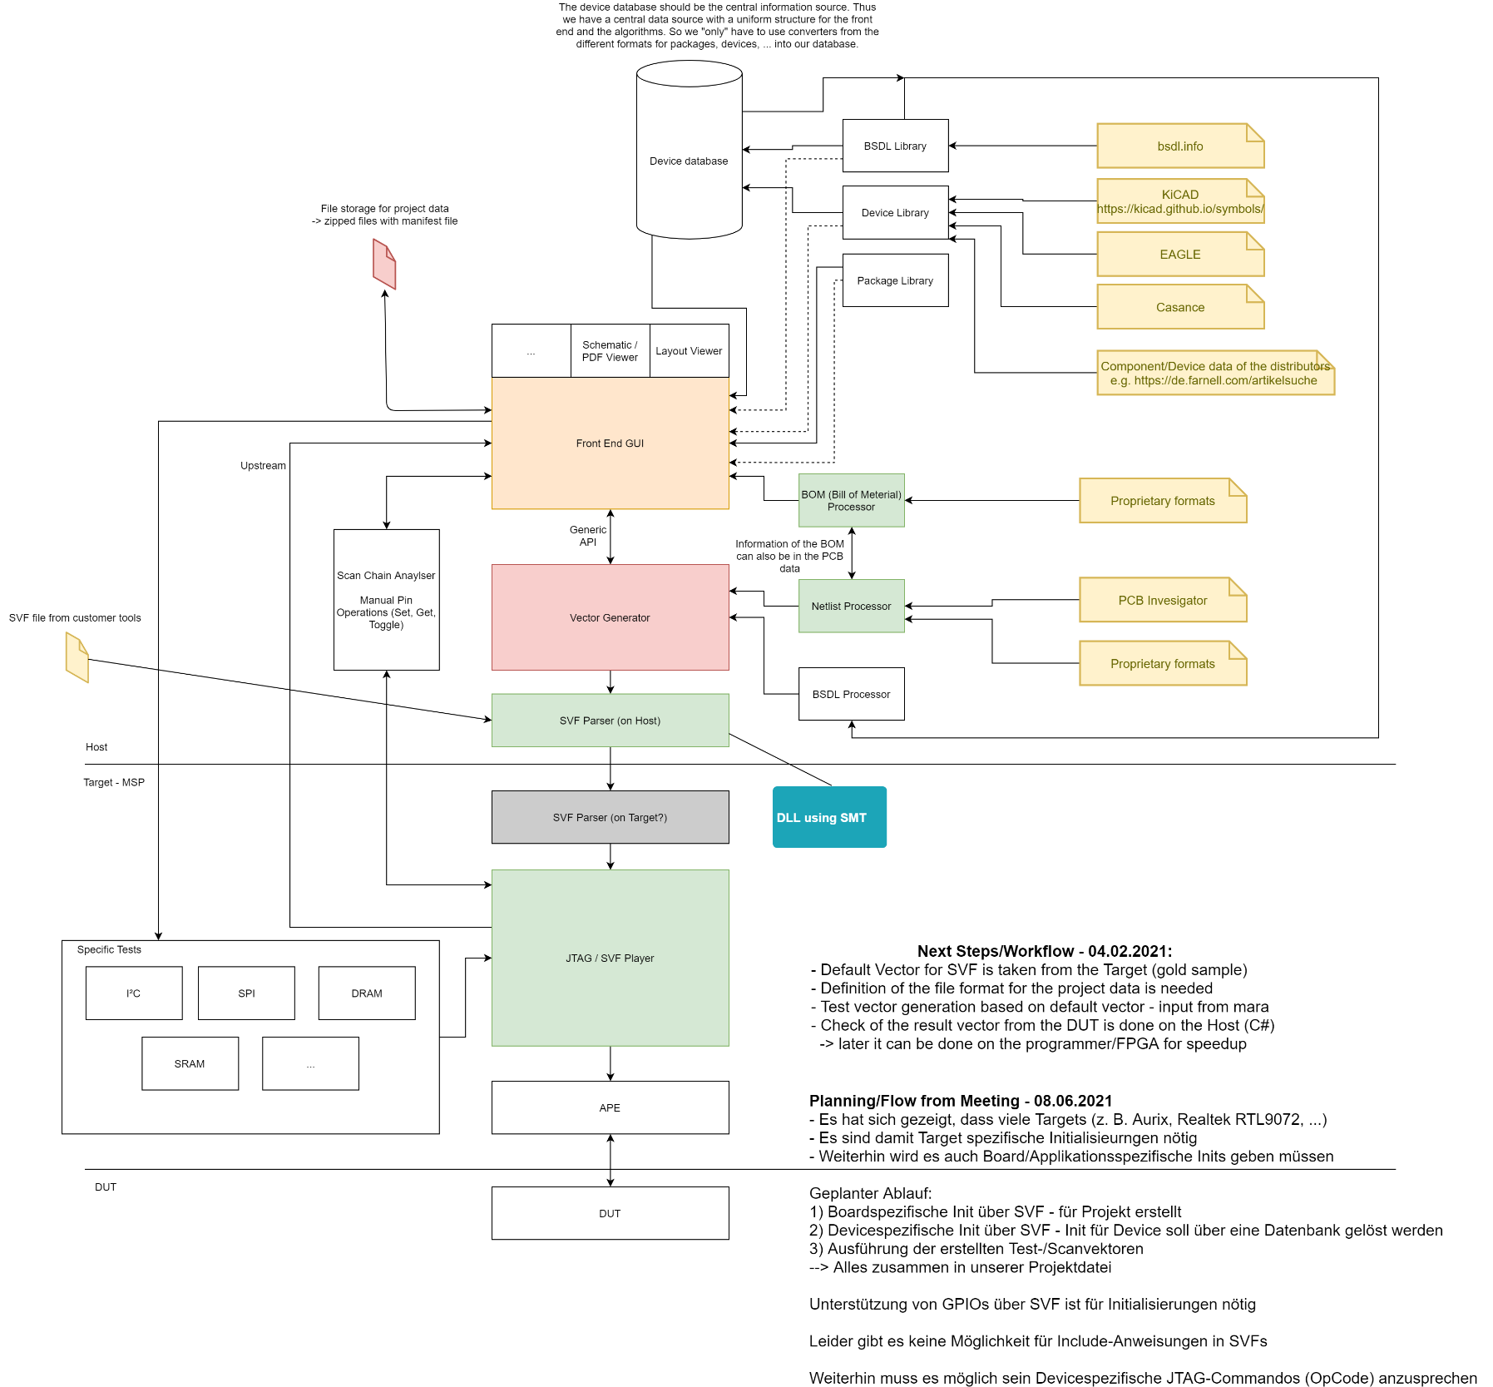
Figure 2: Architecture Overview
The image of Figure 2 can be found in: https://gitlab.promik.local/flash_task/host/smart_ict_analyser/-/blob/master/doc/Concept/SMART%20ICT%20Concept.png.

Control of the targets
The current implementation considers each JTAG target independently. This means that parallel execution of the boundary scan tests is also possible for several ICs.
The disadvantage of this solution is that synchronous testing of the connections between different boundary-scan-capable ICs on an ECU is not possible.
Synchronisation between the targets is necessary for this. After consultation with Martin, there are 2 solutions here:
- Synchronisation of the test vectors at the software level. To make synchronisation between different programmers possible, this function must be implemented on the host side.
- Interconnection of the targets to a virtual scan chain via the programmer. This requires adapted SVF test vectors and only works for one programmer. The advantage is that synchronisation is ensured by the boundary scan functionality.
After considering the options, solution 1. is considered the preferred implementation.

Recognised patterns and test cases
The recognised structures in the circuit diagram and the test patterns derived from them are described below.
It should be noted that the schematic is evaluated based on the data from the PCB Investigator. The ICs that have a JTAG interface and thus optically support boundary scan are determined first.
Based on these detected ICs, the circuits at the pins are now examined. Depending on the detected circuitry, the test vectors are generated.
For a better or more targeted generation of test vectors, an extension of the evaluation by SPICE simulation is conceivable. In this case, the wiring of the circuit can be simulated at the respective pin of the IC. In this way, the expected values (0 or 1) for the test vectors can be determined exactly. This also allows any special cases to be intercepted. A POC is to be created as part of a final thesis.
Currently, the test vectors only consider one pin for which the tests are carried out.
Basically, a boundary scan pin consists of either 1, 2 or 3 boundary scan cells. These can be:
- input
- control & output
- control & input & output
If control is set to the safe state, the cells assume the INPUTMODE. If the cells are set to the opposite state, they assume the OUTPUTMODE.
1 cell boundary scan pins can only be read – means TDI can be completely 0.
For 2 and 3 cell versions applies:
- TDI can only be controlled in a meaningful way:
  - CONTROL = INPUT
  - CONTROL = OUTPUT & OUTPUT = EXPECTED VALUE
- TDO can only be read back meaningfully:
  - INPUT (for 3 cells) or OUTPUT (for 2 cells)
The mask must be set according to the position INPUT (for 1 || 3 cells) or OUTPUT (for 2 cells).

Patters and test:
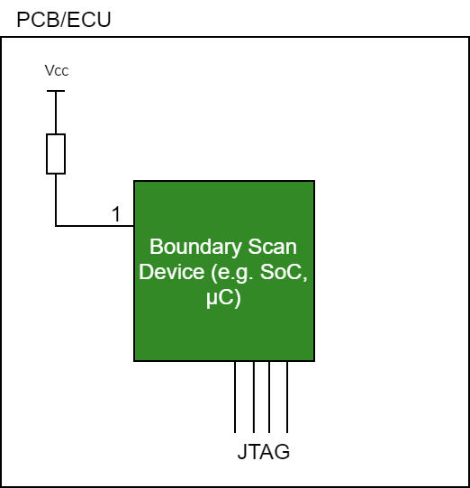
- Pull Ups Resistors – Resistors against net with supply voltage detected:
  - Test for bidir with 3 cells
    - Test case 1:
      - Set TDI[control] = input,
      - Expected TDO [input] = 1
    - Test case 2: T
      - Set TDI[control] = output,
      - Set TDI[output] = 0
      - Expected TDO [input] = 0
  - Test for bidir with 2 cells
    - Test case 1:
      - Set TDI[control] = input,
      - Expected TDO [output] = 1
    - Test case 2:
      - Set TDI[control] = output, TDI[output] = 0
        - Expected TDO [output] = 0

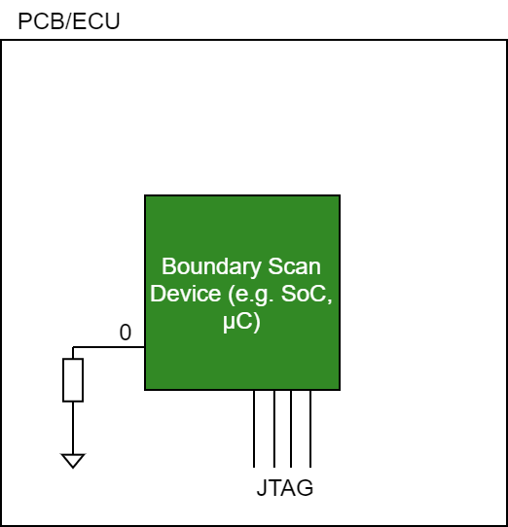
- Pull Down Resistors – Resistors against net with ground voltage detected:
  - Test for bidir with 3 cells
    - Test case 1:
      - Set TDI[control] = input
      - Expected TDO [input] = 0
    - Test case 2:
      - Set TDI[control] = output
      - Set TDI[output] = 1
      - Expected TDO [input] = 1
  - Test for bidir with 2 cells
    - Test case 1:
      - Set TDI[control] = input
      - Expected TDO [output] = 0
    - Test case 2:
      - Set TDI[control] = output
      - Set TDI[output] = 1
      - Expected TDO [output] = 1
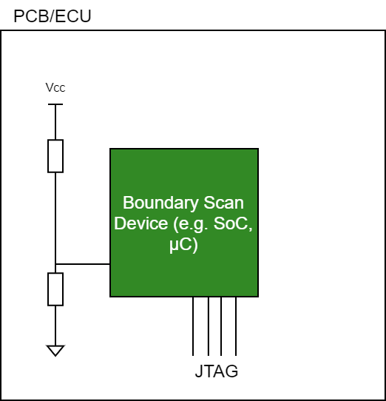
- Pull Up and Pull Down Resistors
This case should not occur in practice.
It is thinkable if:
  - Voltage parts are present at an analogue input and this pin can also be read digitally via boundary scan.
  - Configuration options are set per pin and the placement options in BOM are not correctly specified (pull up and pull down entered)

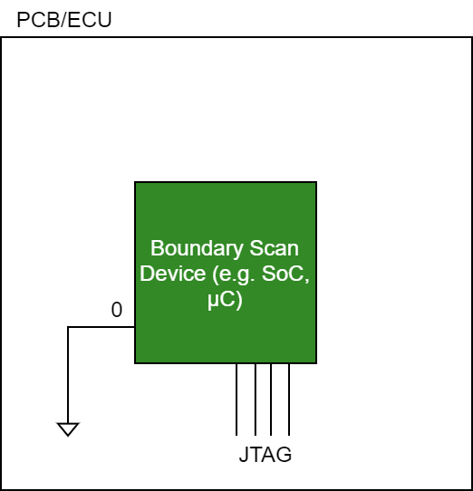
- Direct connection to GND:
  - Test for bidir with 3 cells
    - Test case 1:
      - Set TDI[control] = input
      - Expected TDO [input] = 0
    - Test case 2:
      - Set TDI[control] = output
      - Set TDI[output] = 1
      - Expected TDO [input] = 0
  - Test for bidir with 2 cells
    - Test case 1:
      - Set TDI[control] = input
      - Expected TDO [output] = 0
    - Test case 2:
      - Set TDI[control] = output
      - Set TDI[output] = 1
      - Expected TDO [output] = 0
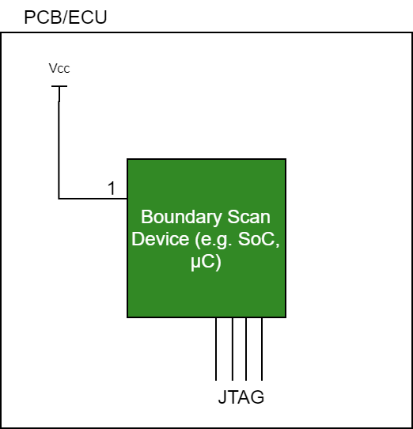
- Direct connection to Power:
  - Test for bidir with 3 cells
    - Test case 1:
      - Set TDI[control] = input
      - Expected TDO [input] = 1
    - Test case 2:
      - Set TDI[control] = output
      - Set TDI[output] = 0
      - Expected TDO [input] = 1
  - Test for bidir with 2 cells
    - Test case 1:
      - Set TDI[control] = input
      - Expected TDO [output] = 1
    - Test case 2:
      - Set TDI[control] = output
      - Set TDI[output] = 0
      - Expected TDO [output] = 1

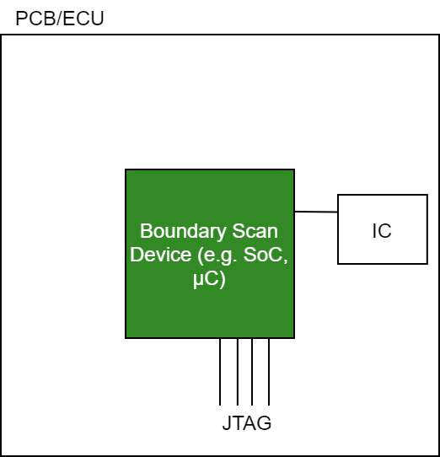
- Pin connected to logic – unknownsControl:
  - Test for bidir with 3 cells
    - Test case 1:
      - Set TDI[control] = output
      - Set TDI[output] = 0
      - Expected TDO [input] = 0
    - Test case 2:
      - Set TDI[control] = output
      - Set TDI[output] = 1
      - Expected TDO [input] = 1
  - Test for bidir with 2 cells
    - Test case 1:
      - Set TDI[control] = output
      - Set TDI[output] = 0
      - Expected TDO [input] = 0
    - Test case 2:
      - Set TDI[control] = output
      - Set TDI[output] = 1
      - Expected TDO [input] = 1

- Pin connected to logic and input – unknownsInput:
  - Test for bidir with 3 cells
    - Test case 1:
      - Set TDI[control] = input
      - Expected TDO [input] = 0
    - Test case 2:
      - Set TDI[control] = input
      - Expected TDO [input] = 1
  - Test for bidir with 2 cells
    - Test case 1:
      - Set TDI[control] = input
      - Expected TDO [input] = 1
    - Test case 2:
      - Set TDI[control] = input
      - Expected TDO [input] = 0

The next step is to extend the tests or test vectors so that the neighbours of the pins are considered in order to detect short circuits with a very high probability.

Integration into the overall process – POnline_Pro
In the context of POnline_Pro, the customer uses a DLL for the integration into his project (e.g. with TestStand). The SVF Player DLL is a solution that, like the Generic CAN DLL, can also be integrated into the project.
It must be ensured that the POnline_Pro DLL and the SVF Player DLL function together in one project and with one programmer.

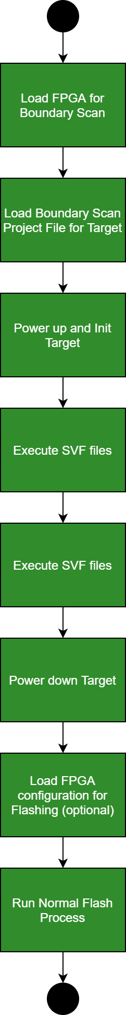
Integration into the overall process – FlashTask_Pro
Figure 3: Flow in Job
There are two points to consider for integration into FlashTask_Pro.

- First, the integration of the Boundary Scan Test into the "normal" programming process must be considered. Here, the flexibility is to be realised as in a programming sequence. This is only possible with integration into the JobEditor/JobFile.
For integration into the existing concept for job-based processing, it is necessary for the boundary scan functionality to act as a "driver". This driver must be a wrapper for the SVF player functionality in SMT. Furthermore, the handling of the SVF project files must be taken into account.
An extension of the existing concept of jobs has to be foreseen. It must be possible to use different FPGA configurations for boundary scan and flashing.

The basic procedure can be seen in Figure 3.

- Furthermore, the integration and display in the GUI must be considered. Here, a separate view is necessary for the Boundary Scan Test, which displays the test cases and, if necessary, the errors with the error message. A display of the faulty component on the PCB is probably not necessary.

Verification and Validation

ZedBoard
The ZedBoard was used for the initial development of the Boundary Scan functionality. With the help of the available LEDs, the control of the correct pins could be checked. This was done at 3 different development stages:
- Initial implementation by mara
- Porting in the SMT by ches
- Generation and use of the test vectors based on the SAMRT ICT Analyser by rama

TriBoard TC3X7 V20
Based on the SMART ICT demo using the TriBoard TC3X7 V20, the first tests of the fault detection were carried out.
The wiring as described in the manual https://gitlab.promik.local/flash_task/host/tools/smart_ict_demo/-/blob/master/docs/documentation.pdf was used.
The pin assignment is described in Figure 4. The specified pins can be switched with a pull up to VCC or a pull down to GND via switches.
Figure 4: SMART ICT wiring
As a basis for testing independent of customer applications, the SMART ICT Demo is to be extended to include all conceivable error cases. For this purpose, the previously free pins of the extension connectors are to be used. These signals are recognised as open (without pull up or pull down) on the basis of the available schematic.
The error cases without extension of the schematic are as follows:
- Pin directly to GND
- Pin directly to VCC
- Pin via pull-up to VCC
- Pin via pull down to GND
- Short circuit of neighbouring pin
- Short circuit on an IC connected to the Boundary Scan Device
The error cases with extension of the schematic are as follows:
- Pull Up in the circuit diagram - Pin open
- Pull Up in the circuit diagram - Pull Down in the circuit
- Pull Down in the circuit diagram - Pin open
- Pull Down in the circuit diagram - Pull Up in the circuit
- Direct connection with two pins in the circuit diagram - connection not there

Definition of tests for TriBoard see https://gitlab.promik.local/flash_task/host/smart_ict_analyser/-/blob/master/doc/Concept/Aurix_TriBoard_Testsetup.xlsx

Customer Application – ADC418AI12
For testing the test cases, the customer application in the form of the ADC418AI12 (ProMik Partnumber 9389380) was used. Based on the available data (ODB++, BOM and BSDL), all possible test cases were generated and executed. The problems that occurred were investigated and resolved. As a result, meaningful tests for the S32G2 and the RTL9072AAD could be carried out.
The results for the tests have been completed:
- S32G2 - https://gitlab.promik.local/flash_task/host/smart_ict_analyser/-/issues/20#note_107167
- RTL9072AAD - https://gitlab.promik.local/flash_task/host/smart_ict_analyser/-/issues/20#note_106918
Here some tests are Failed. However, this can be explained by errors in the BOM and is explained in the document https://gitlab.promik.local/flash_task/host/smart_ict_analyser/uploads/8afb2388d4e57cb56b13c3955aaee27f/MISSMATCHES_ANALYZES.txt.

After completion of the good-case tests, fault cases were injected into the hardware. Based on the wiring diagram, the following errors were selected:
Errors on RTL9072AAD:
- Remove Pulldowns: R22112 + R22072
- Add Short between: R22016 + R22017
- Change Pulldown to Pullup: R22015

Errors on S32G2:
- Add Pulldown: R41024
- Remove Pulldown: R41055
- Change Pulldown to Pullup: R41086
- Add Short between: R41102 + R41103
The execution of the tests has shown that:
- S32G2 error at R41024 leads to reset of the ECU - Power Good Signal of the PMIC
- RTL9072AAD of the pins of the switch with injected faults is boundary scan capable - was only checked afterwards.
To be done:
- Execution and documentation of the current test cases
- New test cases for RTL9072AAD needed
- More tests with Fixure and current samples - ProMik Partnumber 7251226

Milestone Plan
No. | Target Date | Responsible | Description
1 | KW31 | RAMA | Verification of the generated test vectors on customer boards – ADC418 with fixure  - Good case  - Error case
2 | KW31 | KRTR | Planning the expansion of the TriBoard to include all conceivable test cases - Circuitry  Checking the effort for implementation - components, ...
3 | KW31 | RAMA | Extension of the generated test vectors with regard to the detection of short circuits to neighbouring pins
4 | KW34 | MAME/Lab | Implementation of the TriBoard extension
5 | KW34 | SERE/ALDA | Integration in JobEditor
6 | KW35 | DMCE/ALDA | FlashTask_Pro Integration
7 | KW36 (Because of holiday) | RAMA | Verification of the test vector using the TriBoard with extension
8 | KW38 | RAMA | Extension/optimisation of the test vector generation with regard to testing several pins with one vector
9 | KW38 | ALDA/RAMA | Revision of the interface and workflow of the SMART ICT Analyser

Usage of the console application library
There have been provided different library projects which could be further be included by Nuget packages for different kind of purposes.

ProjectFileHandler
- Project name in SmartIctTool solution
  - ConsoleApplication/ProjectFileHandler
- Nuget package name
  - ProMik.SmartIct.Console.ProjectFileHandler
- Project location in Git
  - https://gitlab.promik.local/flash_task/host/smart_ict_analyser/-/tree/master/SmartIctTool/ConsoleApplication/ProjectFileHandler
- Purpose
  - The included interface IProjectFileHandler provides a couple of different methods for being able to read out / update or create information regarding the project files (.sfvproj)

All methods in detail
Task<Result<byte[]>> GetOdbProjectZipFolder(string svfProjectFilePath)
Provides the whole odb project as byte array from the project file which is located under svfProjectFilePath for being able to create a zip file locally.
Task<Result<byte[]>> GetJsonProjectFile(string svfProjectFilePath)
Provides the JSON formatted file content as byte array from the project file which is located under svfProjectFilePath.
Task<Result<byte[]>> GetSettingsFile(string svfProjectFilePath)
Provides the settings file content as byte array from the project file which is located under svfProjectFilePath.
Task<Result<SettingsContent>> GetSettingsContent(string svfProjectFilePath)
Provides the settings file content as SettingsContent object from the project file which is located under svfProjectFilePath.
Task<Result<byte[]>> GetBomFile(string svfProjectFilePath)
Provides the bom file content as byte array from the project file which is located under svfProjectFilePath.
Task<Result<BomSettings>> GetBomSettingsContent(string svfProjectFilePath)
Provides the bom settings content as BomSettings object from the project file which is located under svfProjectFilePath.
Task<Result<byte[]>> GetBomSettingsFile(string svfProjectFilePath)
Provides the bom settings content as byte array from the project file which is located under svfProjectFilePath.
Task<Result<Dictionary<string, Stream>>> GetBsdlFiles(string svfProjectFilePath)
Provides a dictionary containing the JTAG name as key and the (memory-)stream of the related BSDL file content as value from the project file which is located under svfProjectFilePath.
Task<Result<Dictionary<string, byte[]>>> GetBsdlFilesContent(string svfProjectFilePath)
Provides a dictionary containing the JTAG name as key and the byte array content of the related BSDL file as value from the project file which is located under svfProjectFilePath.
Task<Result<Manifest>> GetManifestContent(string svfProjectFilePath)
Provides manifest content as Manifest object from the project file which is located under svfProjectFilePath.
Task<Result<ProjectFileContent>> CreateProjectFile(
string odbProjectFolderPath,
byte[] jsonProject,
SettingsContent settingsJsonContent,
string bomFilePath,
BomSettings bomSettings,
List<SvfPathWrappedBsdlContainer> bsdl,
string destinationFileName)
Creates a new svfproj file at the location specified by destinationFileName containing the following data:
- ODB project – the whole folder specified under odbProjectFolderPath will be considered as the ODB project files
- JSON project – the byte array of jsonProject will be considered for that field
- Settings JSON file – the settingsJsonContent object will be considered for creation of that data
- Bom file – the file from bomFilePath will be considered for that data
- Bom settings file – the bomSettings object will be considered for that data
- The BSDL files – That information will be taken from the BSDLFileToBeUsed property of the bsdl content
- The Svf files – All the paths which are specified under SvfPathsToUseFromLocalSystem wihin the bsdl content will be considered for that data
Task<Result<ProjectFileContent>> CreateProjectFile(
string odbProjectFolderPath,
byte[] jsonProject,
SettingsContent settingsJsonContent,
string bomFilePath,
BomSettings bomSettings,
List<SvfDataWrappedBsdlContainer> bsdl,
string destinationFileName)
Creates a new svfproj file at the location specified by destinationFileName containing the following data:
- ODB project – the whole folder specified under odbProjectFolderPath will be considered as the ODB project files
- JSON project – the byte array of jsonProject will be considered for that field
- Settings JSON file – the settingsJsonContent object will be considered for creation of that data
- Bom file – the file from bomFilePath will be considered for that data
- Bom settings file – the bomSettings object will be considered for that data
- The BSDL files – That information will be taken from the BSDLFileToBeUsed field of the bsdl content
- The Svf files – All the data from the field SvfDataFiles wihin the bsdl content will be considered for that data
Task<Result<ProjectFileContent>> CreateProjectFile(
string odbProjectFolderPath,
byte[] jsonProject,
SettingsContent settingsJsonContent,
string bomFilePath,
BomSettings bomSettings,
List<WrappedBsdlContainer> bsdl,
string destinationFileName)
Creates a new svfproj file at the location specified by destinationFileName containing the following data:
- ODB project – the whole folder specified under odbProjectFolderPath will be considered as the ODB project files
- JSON project – the byte array of jsonProject will be considered for that field
- Settings JSON file – the settingsJsonContent object will be considered for creation of that data
- Bom file – the file from bomFilePath will be considered for that data
- Bom settings file – the bomSettings object will be considered for that data
- The BSDL files – That information will be taken from the BSDLFileToBeUsed field of the bsdl content
- The Svf files – no svf files at all will be considered by this method
Task<Result<ProjectFileContent>> GetProjectFileContent(string svfProjectFilePath)
Provides the whole project file content as ProjectFileContent object from the project file which is located under svfProjectFilePath.
Task<Result> UpdateOdbProjectZipFolder(string svfProjectFilePath, string odbPath)
Updates just the ODB project file content by the field odbPath within the project file located under svfProjectFilePath
Task<Result> UpdateJsonProjectFile(string svfProjectFilePath, byte[] jsonData)
Updates just the JSON project content by the field jsonData within the project file located under svfProjectFilePath
Task<Result> UpdateSettingsContent(string svfProjectFilePath, SettingsContent settingsContent)
Updates just the JSON settings file content by the field settingsContent within the project file located under svfProjectFilePath
Task<Result> UpdateBomFile(string svfProjectFilePath, byte[] bomContent)
Updates just the bom file content by the field bomContent within the project file located under svfProjectFilePath
Task<Result> UpdateBomSettingsContent(string svfProjectFilePath, BomSettings bomSettings)
Updates just the bom settings content by the field bomSettings within the project file located under svfProjectFilePath
Task<Result> UpdateBsdlContent(string svfProjectFilePath, List<WrappedBsdlContainer> bsdlContent)
Updates just all BSDL file contents by the field bsdlContent within the project file located under svfProjectFilePath
Task<Result> UpdateManifestContent(string svfProjectFilePath, Manifest manifest)
Updates just the manifest content by the field manifest within the project file located under svfProjectFilePath
Task<Result> UpdateSvfFiles(string svfProjectFilePath, List<ISvfData> svfFiles, bool firstDeleteAllContent = true)
Updates just all the svf files which are being provided by the field svfFiles within the project file located under svfProjectFilePath. If the parameter firstDeleteAllContent is set to true then all svf files will be first deleted before updating the content. Otherwise just the svf files with the same name will be overwritten and the other stay saved
Task<Result> UpdateSvfFiles(string svfProjectFilePath, string jtagName, SvfPath svfPathsToUse, bool firstDeleteAllContent = true)
Updates just all the svf files which are being provided by the field svfPathsToUse within the project file located under svfProjectFilePath (reads out all files from the paths specified here). Further there must be provided the jtagName of the specific BSDL entry to be updated. If the parameter firstDeleteAllContent is set to true then all svf files will be first deleted before updating the content. Otherwise just the svf files with the same name will be overwritten and the other stay saved

ProjectLoadHandler
- Project name in SmartIctTool solution
  - ConsoleApplication/ProjectLoadHandler
- Nuget package name
  - ProMik.SmartIct.Console.OdbProjectExtractor
- Project location in Git
  - https://gitlab.promik.local/flash_task/host/smart_ict_analyser/-/tree/master/SmartIctTool/ConsoleApplication/ProjectLoadHandler
- Purpose
  - The included interface IOdbProjectExtractor provides a couple of different methods for being able to transform the ODB++ project related data from ODB++ project or JSON valid file into IPCBComponent and INetComponent objects

All methods in detail
Task<Result<IParsedResult>> GetParsedObjectsFromGrpcByZipFolder(SettingsContent settings, string pathToOdb)
Considering all necessary settings from the settings parameter and the path to the ODB++ project by pathToOdb there will be tried to connect to the PcbInvestigatorApiV10 project which should be running as a GRPC server in background and then read out all necessary objects from the ODB++ project. The following properties of the parameter settings are being used:
- PcbInvestigator.StepsToReadOut
- General.ResistorIdentifier
- General.CapacitorIdentifier
- General.InductionIdentifer
- General.TestPointIdentifier
- General.IcIdentifier
- General.ConnectorIdentifier
- General.UseContains

Task<Result<IParsedResult>> GetParsedObjectsFromGrpcByZipFolder(SettingsContent settings, byte[] odbContentAsZip)
Considering all necessary settings from the settings parameter and the byte array of the ODB++ project in zip compressed file by odbContentAsZip there will be tried to connect to the PcbInvestigatorApiV10 project which should be running as a GRPC server in background and then read out all necessary objects from the ODB++ project. The following properties of the parameter settings are being used:
- PcbInvestigator.StepsToReadOut
- General.ResistorIdentifier
- General.CapacitorIdentifier
- General.InductionIdentifer
- General.TestPointIdentifier
- General.IcIdentifier
- General.ConnectorIdentifier
- General.UseContains
Task<Result<string>> GetDataAsJsonString(IParsedResult result)
This method returns a valid JSON project string of all components which are being included in the parameter result
Task<Result<IParsedResult>> GetParsedObjectsFromJsonFile(GeneralSettings settings, string jsonData)
This method returns the objects of a JSON valid text content in the parameter jsonData and considering the settings of the parameter settings for it. The following properties of the parameter settings are being used:
- ResistorIdentifier
- CapacitorIdentifier
- InductionIdentifer
- TestPointIdentifier
- IcIdentifier
- ConnectorIdentifier
- UseContains
Task<Result<bool>> ChangeIpAdressOfClient(string ip)
If the IP address changed (parameter ip) to not the local host one then this method should be called before trying to connect to the GRPC server
Task<Result<bool>> IsGrpcServerAvailable()
This method could be used to determine whether the Grpc server is available or not
Task<ProMik.Core.Interfaces.Results.Result> UpdateBom(IParsedResult data, string bomFilePath, BomSettings bomSettings)
This method could be used for updating all values of objects by bom data considering all objects by the parameter data, the file path of the bom file by the parameter bomFilePath and the settings of the parameter bomSettings. The following properties of the parameter bomSettings are being used:
- ColRef
- ColValue
Task<ProMik.Core.Interfaces.Results.Result> UpdateBom(IParsedResult data, byte[] bomFileContent, BomSettings bomSettings)
This method could be used for updating all values of objects by bom data considering all objects by the parameter data, the content as byte array of the bom file by the parameter bomFileContent and the settings of the parameter bomSettings. The following properties of the parameter bomSettings are being used:
- ColRef
- ColValue

BoundaryScanObjectDeterminationHandler
- Project name in SmartIctTool solution
  - ConsoleApplication/BoundaryScanObjectDeterminationHandler
- Nuget package name
  - ProMik.SmartIct.Console.BoundaryScanObjectDetermination
- Project location in Git
  - https://gitlab.promik.local/flash_task/host/smart_ict_analyser/-/tree/master/SmartIctTool/ConsoleApplication/ BoundaryScanObjectDeterminationHandler
- Purpose
  - The included interface IBoundaryScanObjectDetermination provides one method for being able to get all the boundary scan related objects of all nets and considering the settings

All methods in detail
Task<ITestCoverageDataModel> GetBoundaryScanRelatedObjects(
IList<INetComponent> allNets,
TestCoverageSettings settings,
bool removeAllComponentsWithoutAnyValues)
This method returns in detail lists of objects of all Jtag components, pull up resistors, pull down resistors and others components of the provided nets by the parameter allNets and considering the settings by the parameter settings. Further by the parameter removeAllComponentsWithoutAnyValues it could be set whether all components which have no values defined at all just should be removed or not at the end of determination. The following properties of the parameter settings are being used:
- GndIdentifier
- GndBlacklist
- PowerIdentifier
- PowerBlacklist
- JtagIdentifier
- JtagBlacklist

JtagPinInformationHandler
- Project name in SmartIctTool solution
  - ConsoleApplication/JtagPinInformationHandler
- Nuget package name
  - ProMik.SmartIct.Console.JtagPinInformationExtractor
- Project location in Git
  - https://gitlab.promik.local/flash_task/host/smart_ict_analyser/-/tree/master/SmartIctTool/ConsoleApplication/JtagPinInformationHandler
- Purpose
  - The included interface IJtagPinInformationExtractor provides one method for being able to get all the boundary scan related pin information of all JTAG devices of all test related objects

All methods in detail
Task<List<JtagConnectionInfo>> GetAllPinInformation(
ITestCoverageDataModel testCoverageData,
TestCoverageSettings settings,
List<IPCBComponent> allComponents,
Action<string, LogCategory> loggerAction)
This method determines all pin information of all JTAG related devices of the parameter testCoverageData, considering all settings of the parameter settings. Further it needs all components of the whole project by the parameter allComponents and a logging action which will be called in case of logging purposes by the parameter loggerAction. The following properties of the parameter settings are being used:
- GndIdentifier
- PowerIdentifier
- JtagIdentifier

SvfFileCreationHandler
- Project name in SmartIctTool solution
  - ConsoleApplication/SvfFileCreationHandler
- Nuget package name
  - ProMik.SmartIct.Console.SvfFileCreator
- Project location in Git
  - https://gitlab.promik.local/flash_task/host/smart_ict_analyser/-/tree/master/SmartIctTool/ConsoleApplication/SvfFileCreationHandler
- Purpose
  - The included interface ISvfFileCreator provides a couple of methods for being able to create all svf files of a jtag device considering the BSDL file

All methods in detail
Task<Result<(byte[] defaultVector, uint idCode)>> GetDefaultVectorOfDevice(
WrappedProgrammerSettings programmer,
Stream bsdlContentStream,
Action<string, LogCategory> loggerAction,
bool allowCalculationOfVector = true,
bool justUseCalculatedVector = false)
This method tries to read out the default vector of the connected device by considering all settings by the parameter Programmer and the BSDL stream by the parameter bsdlContentStream. Further, it uses a loggerAction parameter to forward all logging actions occurred. Finally, by the parameter allowCalculationOfVector it is possible to define whether in case of failed read out of the vector the calculation by the BSDL file is allowed and by the parameter justUseCalculatedVector it is possible to skip the read out of the device completely and just use the calculated one. The following properties of the parameter programmer are being used:
- Ip
- Port
- SupplyVoltage
- IoVoltage
- Frequency
- CableCompensation
- Target
- Slot
Task<Result<SvfHandleResult>> GetSvfFilesForJtagDevice(
JtagConnectionInfo jtag,
Stream bsdlContentStream,
byte[] defaultVector,
uint idCode,
Action<string, LogCategory> loggerAction,
string jtagAliasName = "")
This method is being used to create all svf files of a specific JTAG device, provided by the parameter jtag and the BSDL content of the stream parameter bsdlContentStream. Further it needs the previously created defaulVector and the read out idCode of the device. Finally there is the possibility of defining a JTAG alias name which should be considered for all created svf files and a loggerAction which should be performed in case of logging actions.
Task<Result> SaveSvfFilesToPath(List<ISvfData> svfFiles, string destinationPath)
This method could be used to save all svf files provided by the parameter svfFiles to a local path by the parameter destinationPath.

BoundaryScanReportHandler
- Project name in SmartIctTool solution
  - ConsoleApplication/BoundaryScanReportHandler
- Nuget package name
  - ProMik.SmartIct.Console.BoundaryScanReportCreator
- Project location in Git
  - https://gitlab.promik.local/flash_task/host/smart_ict_analyser/-/tree/master/SmartIctTool/ConsoleApplication/BoundaryScanReportHandler
- Purpose
  - The included interface IBoundaryScanReportCreator provides one method for being able to create a csv report file of the previously created svf files of one specific JTAG device

All methods in detail
Task<Result> CreateCsvReport(
JtagConnectionInfo jtag,
List<ISvfData> svfFiles,
List<PinTestTypeContainer> pinInformation,
string jtagName,
string destinationFileName,
Action<string, LogCategory> loggerAction)
This method could be used for creation of a csv report file at the destination destinationFileName, considering the JTAG related device information by the parameter jtag, all created svf files by the parameter svfFiles, all created pininformation of the parameter pinInformation, the jtag name itself by the parameter jtagName and finally a loggerAction which will be called in case of logging actions.

Sequence diagram of the whole usage
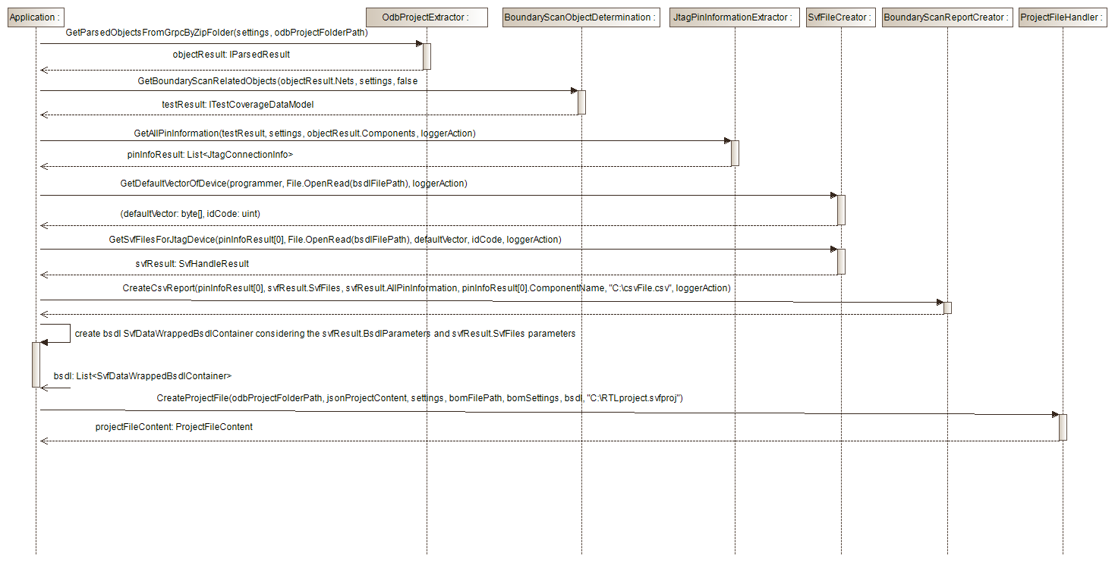

Usage example with source code
The following example describes a complete work flow of
    - Read out data of a ODB++ project path (GRPC server must be running for that in the background)
    - Update all values by a BOM content
    - Determine the boundary scan related objects
    - Create all JTAG related pin information
    - Read out the default vector (The device should be connected to a running programmer)
    - Create all SVF files
    - Create a project file
Source code:
- // create a valid settings content
- SettingsContent settingsContent = new SettingsContent()
- {
- General = new GeneralSettings()
- {
- CapacitorIdentifier = "c",
- ConnectorIdentifier = "x",
- IcIdentifier = "i",
- InductionIdentifer = "l",
- ResistorIdentifier = "r",
- TestPointIdentifier = "tp",
- UseContains = true,
- },
- GrpcServer = new GrpcServerSettings()
- {
- IpAddress = "127.0.0.1",
- },
- PcbInvestigator = new PcbInvestigatorSettings()
- {
- StepsToReadOut = "-1",
- },
- Programmer = new WrappedProgrammerSettings()
- {
- CableCompensation = 0,
- Frequency = 15000,
- Id = 0,
- IoVoltage = 5000,
- Ip = "192.168.1.2",
- Port = 5005,
- Slot = 0,
- Target = 0,
- SupplyVoltage = 3000,
- },
- TestCoverage = new TestCoverageSettings()
- {
- GndBlacklist = "",
- GndIdentifier = "gnd",
- JtagBlacklist = "",
- JtagIdentifier = "tms;tdi;tdo",
- PowerBlacklist = "",
- PowerIdentifier = "4v;1v;3.3v",
- }
- };

- // read out the ODB++ project path content
- string odbProjectPath = @"C:\Repositories\smart_ict_analyser\Testdaten\ADC418\odb\new_vom_25.11.21";
- IOdbProjectExtractor projectLoadHandler = new OdbProjectExtractor();
- var projectLoadResult = await projectLoadHandler.GetParsedObjectsFromGrpcByZipFolder(
- settingsContent, odbProjectPath).ConfigureAwait(true);
- if (!projectLoadResult.Success)
- {
- Debug.WriteLine(projectLoadResult.Message);
- return;
- }

- // update the BOM file content
- string bomFilePath = @"C:\Repositories\smart_ict_analyser\Testdaten\ADC418\BOM\BOM_PES_Var_ADC418AI12_DDR8Gb_C1_new_0_4.CSV";
- BomSettings bomSettings = new BomSettings(";", "0", "4");
- var bomResult = await projectLoadHandler.UpdateBom(
- projectLoadResult.Data,
- bomFilePath,
- bomSettings).ConfigureAwait(true);
- if (!bomResult.Success)
- {
- Debug.WriteLine(bomResult.Message);
- }

- // read out the boundary scan related objects
- TestCoverageSettings testCoverageSettings = settingsContent.TestCoverage;
- IBoundaryScanObjectDetermination boundaryScanDeterminationHandler = new BoundaryScanObjectDetermination();
- var boundaryScanDeterminationResult = await boundaryScanDeterminationHandler.GetBoundaryScanRelatedObjects(
- projectLoadResult.Data.Nets,
- testCoverageSettings,
- false).ConfigureAwait(true);

- // create the pin JTAG information
- IJtagPinInformationExtractor pinInformationHandler = new JtagPinInformationExtractor();
- var pinInfosResult = await pinInformationHandler.GetAllPinInformation(
- boundaryScanDeterminationResult,
- testCoverageSettings,
- projectLoadResult.Data.Components.ToList(),
- (message, category) => Debug.WriteLine(message)).ConfigureAwait(true);

- ISvfFileCreator svfHandler = new SvfFileCreator();
- string bsdlFile = @"C:\Repositories\smart_ict_analyser\Testdaten\ADC418\BSDL\S32G274A_SBGA_1830101D_v2p0.bsdl";

- // read out the default vector
- var defVectorResult = await svfHandler.GetDefaultVectorOfDevice(
- settingsContent.Programmer,
- File.OpenRead(bsdlFile),
- (msg, cat) =>
- {
- Debug.WriteLine(msg);
- }, true, true);

- if (!defVectorResult.Success)
- {
- Debug.WriteLine(defVectorResult.Message);
- return;
- }

- // create all svf files
- var svfCreationResult = await svfHandler.GetSvfFilesForJtagDevice(
- pinInfosResult[0],
- File.OpenRead(bsdlFile),
- defVectorResult.Data.defaultVector,
- defVectorResult.Data.idCode,
- (msg, cat) =>
- {
- Debug.WriteLine(msg);
- },
- "S32P");

- if (!svfCreationResult.Success)
- {
- Debug.WriteLine(svfCreationResult.Message);
- return;
- }

- // Don't forget to place the programmer settings into the newly created BSDL container
- svfCreationResult.Data.BsdlParameters.ProgrammerSettings = settingsContent.Programmer;

- // transform the read out data into a JSON valid string data
- var projectDataTransformResult = await projectLoadHandler.GetDataAsJsonString(projectLoadResult.Data).ConfigureAwait(true);
- if (!projectDataTransformResult.Success)
- {
- Debug.WriteLine(projectDataTransformResult.Message);
- return;
- }

- // write the project file
- byte[] jsonProjectContent = Encoding.ASCII.GetBytes(projectDataTransformResult.Data);
- List<SvfDataWrappedBsdlContainer> bsdl = new List<SvfDataWrappedBsdlContainer>();
- bsdl.Add(new SvfDataWrappedBsdlContainer(svfCreationResult.Data.BsdlParameters, bsdlFile, svfCreationResult.Data.SvfFiles));
- string destinationFileName = @"C:\Repositories\smart_ict_analyser\Testdaten\Project files\new_created_project.svfproj";
- IProjectFileHandler projectFileHandler = new ProjectFileHandler();
- var resultProjectCreate = await projectFileHandler.CreateProjectFile(
- odbProjectPath, jsonProjectContent, settingsContent, bomFilePath, bomSettings, bsdl, destinationFileName).ConfigureAwait(true);
- if (!resultProjectCreate.Success)
- {
- Debug.WriteLine(resultProjectCreate.Message);
- }

